**Choice of Engine:**

When deciding the engine to develop our project in, there were two major contenders:

**Unity 2018**



There are several advantages to using Unity to develop our project. All programmers have a large amount of Unity experience, having developed several projects using the engine in the past, and extensive knowledge of C#. As well as this, Unity’s simple build tools allow for the game to be quickly and easily built and tested. However, the designers on the team, who will be doing modelling and environment design and using the engine’s GUI more than the programmers, are unfamiliar with Unity’s development environment. This means that the designers would have to learn and use an entirely new environment and systems in order to work on the game.

**Unreal Engine 4.23.1**

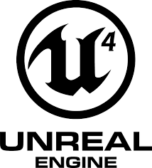

Unreal engine is more familiar to the designers, and the particle systems, animation systems and level design elements have all been used by them in the past. The programmers, however, are inexperienced with Unreal Engine, and while knowing how to use C++, have not tried to use Unreal’s namespace and built-in functionality in the past. However, Unreal Engine also provides many tools and features to assist with coding, attaching to Visual Studio and has extensive documentation. This should allow the programming team to be able to work in Unreal and use their C++ skills, even without prior knowledge of how it works.

Therefore, Unreal Engine will be used to develop this project. It makes sense to use the program the designers are more familiar with, as the GUI will mostly be used by them. Integration with visual studio allows the programming team to use intelli-sense to assist with any unknown functions and parameters and will hopefully lead to a more polished final project.